Wonderous Things (Page 1 of 2) ( capo 2nd fret)
Psalm 86: 10-13 Arranged by Paul Ellingsen

Chorus:
G D C G
For you are great and do wondrous things
G D G C2 G
You alone are God

G D C G
All Nations You’ve made shall worship be-fore you
D G C2 G
And shall glorify Your name

G D C G
Teach me Your ways Lord, I will walk in your truth
D G C2 G
Unite my heart to fear your name

G D C G
I will praise you oh Lord my God
D G C2 G
With all of my heart

G D C G
I will glorify your name forevermore
D G C2 G
Great is your mercy towards me

Wonderous Things (Page 2 of 2) ( capo 2nd fret)
Psalm 86: 9-13 Arranged by Paul Ellingsen

Chorus:
G D C G
For you are great and do wondrous things
G D G C2 G
You alone are God

G D C G
You have delivered My soul from the depths of hell
D G C2 G
You alone are God

G D C G
For you are great and do wondrous things
G D G C2 G
You alone are God
G D G C2 G
You alone are God
G D G C2 G
You alone are God
G C C2 D
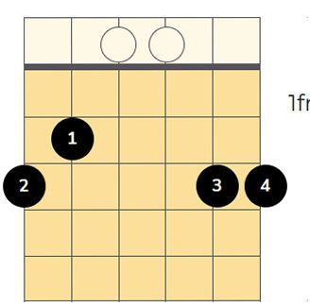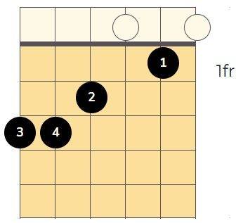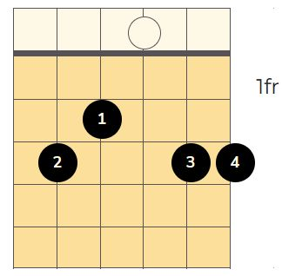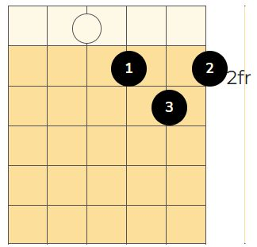

A 2-Edged Sword (Capo 2nd fret)
Hebrews 4:12-13 Arranged by Paul Ellingsen

Gmaj6 Cmaj7
II : The word of God is sharper than any two-edged sword
Gmaj6 D2
Living and powerful is God’s holy word
Gmaj6 Cmaj7 Gmaj6
Piercing soul and spirit and of joints and mar-row
D2 Gmaj6
And a discerner of the thoughts and in-tents of the heart :II

C Em D2
II: And there is no crea-ture hidden from His sight
C Em D2
But all things are naked to His eyes :II
C D2 Gmaj6
II: And to Him we must give ac-count :II
C D G
And to Him we must give ac-count

Gmaj6 Cmaj7 D2 D Em
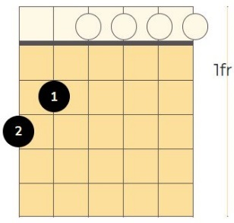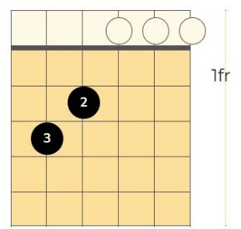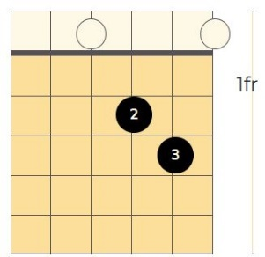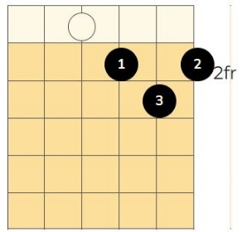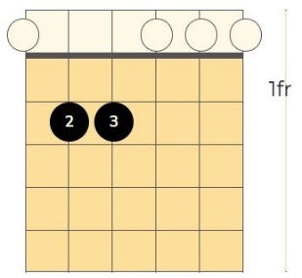

To the Glory of God the Father (capo 2nd fret)
Philippians 2:5-11 musical arrangement by Paul Ellingsen
G C9 Dm11 C9 G C9 Dm11 C9

G C9 Dm11 C9 G C9 Dm11 C9
Let this mind be in you which was also in Christ Jesus,
G C9 Dm11 C9 G C9 Dm11 C9
who, being in the form of God, did not con-sider it rob-be-ry
G C9 Dm11 C9 G C9 Dm11 C9
to be equal with God, but made Him-self of no repu-tation,
G C9 Dm11 C9 G C9 Dm11 C9
taking the form of a bond-servant, and coming in the like-ness of men.
D2 C9 Dm11 C9 D2
And being found in appearance as a man, He hum--bled Him-self
D2 C9 Dm11 C9 D2
and became obedient even to the point of death,
D2 C9 Dm11 C9
even the death of the cross. Therefore God highly ex-alted Him
G C9 Dm11 C G C9 Dm11 C9
and given Him a name which is a-bove every name,
G C9 Dm11 C9 G C9 Dm11 C9
that at the name of Je-sus ev-------ery knee it should bow,
G C9 Dm11 C9 G C9 Dm11 C9
of those in hea-ven, and of those on earth,
G C9 Dm11 C9 G C9 Dm11 C9
and even those who are under the earth,
D2 C9 Dm11 C9
that every tongue should confess that Jesus Christ is Lord of all X3
G C9 Dm11 C9 G C9 Dm11 C9 G
to the glory of Go--d the Father. X3
G C9 Dm11 D2
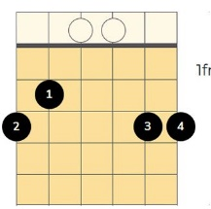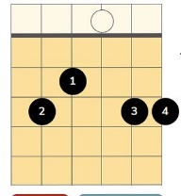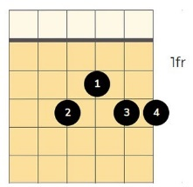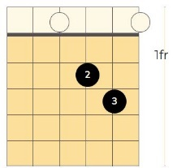

It is Good to Give Thanks
Psalm 92:1-4 Music arraignment by Paul Ellingsen
D+A Dsus4 D
It is good to give thanks unto the Lord
G A D
And sing praises to your name
D+A Dsus4 D
To declare your lovingkindness in the morn
G A D
your faithfulness every night
G D
On an instrument of six strings
A D
On the lute and on the harp
G D
With a harmonious sound for
A D
Lord You have made me glad
G D
I will triumph in the work of your hands for
A D
You have made me glad x3

D+A Dsus4 D G A
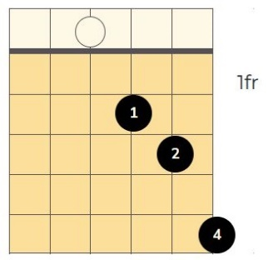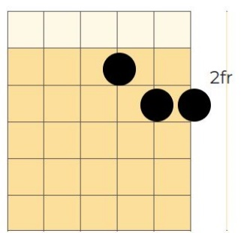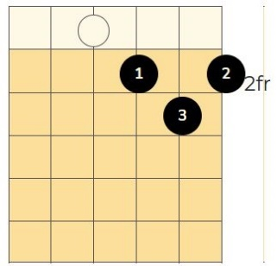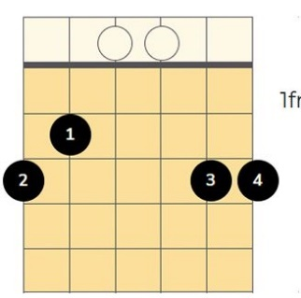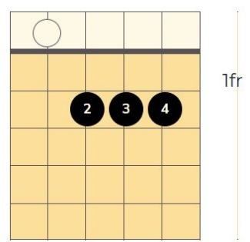

The Lord is Near (Capo 5th fret)
Psalm 145:18-21 Musical arrangement by Paul Ellingsen
G D G
The Lord is near to those who call up-on Him
D G C2 G
Who call up-on Him in truth
D G
He’ll fulfill the desire of those who fear Him
D G C2 G
He will hear their cry and save
D G
The Lord preserves all who love Him
D G C2 G
But the wicked He shall des-troy
C D G
My mouth shall speak of the praise of the Lord
D G C2 G
All flesh shall praise His holy name (x3)
D G C2 G
For-ever and forever a-men (x3)

G C C2 D
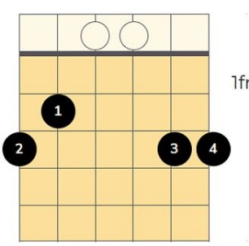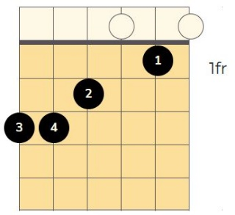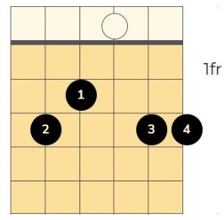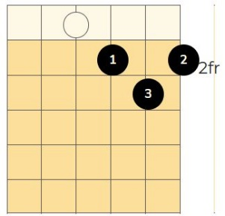

The Lambs Book of Life
Rev 21:27 By Paul Ellingsen (Capo 2nd fret)
Chorus:
G D C G
Is your name written in the lambs book of life
C G C D
When He takes you out of this world of sin and strife
G D C G
When you breathe your last breath in this life
C G C D G
Will you find your name written in the lambs book of life

Last time: G D C G
When you breathe your last breath in this life
C G C D G
Will you find your name written in the lamb’s book of life
C G C D G
Will you find your name written in the lamb’s book of life x2

Verse: G D C G
As another day slowly slips away
C G C D
Did you open His book see what He had to say?
G D C G
He can make your life new He can make you born a-gain
C G C D G
He can change your life He can free you from sin
G C D
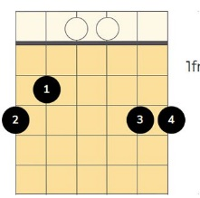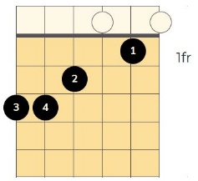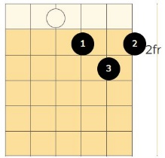
All Flesh Shall Know
By Paul Ellingsen based on Isaiah 49:26 Am
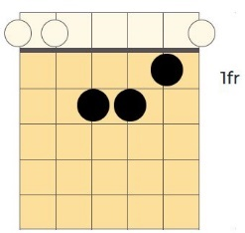
Am Dm Am
All flesh shall know, I am Your re-deem-er
Em Am
The Mighty One of Is--ra—el
Dm
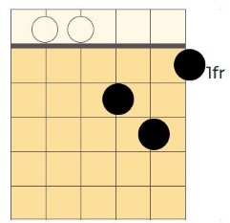
Am Dm Am
All flesh shall know the mighty one of Jacob
Em Am
The Holy One of Is--ra--el
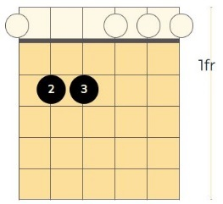
Em
Am Dm Am
All flesh shall know, I have come to save you
Em Am
The Mighty One of Is--ra--el

Am Dm Am
All flesh shall know, that My name is Jesus
Em Am
The Holy One of Is--ra--el

Am Dm Am
All flesh shall know, I gave My life to save you
Em Am
The Humble One of Is--ra--el

Em Am Em Am
The Mighty One of Is--ra—el The Holy One of Is--ra--el

If God is For Us (Page 1 of 2)
Paul Ellingsen (Romans 8:31 Psalm 2:4)
G C2 G Em
If God is for us who can stand against us
C D Em
The Battle for our nation has begun
G C2 G Em
If God is for us who can stand against us
C D G
satan’s dark forces will be overrun

G C2 G Em
If God is for us who can stand against us
C D Em
When we stand with Jesus God’s own Son
G C2 G Em
If God is for us who can stand against us
C D G
When Jesus leads the battle we have won

G C2 G Em
If God is for us who can stand against us
C D Em
He who sits in the heavens shall laugh
G C2 G Em
If God is for us who can stand against us
C D G
The evil one will be vanquished at last

If God is For Us (Page 2 of 2)
Paul Ellingsen (Romans 8:31 Psalm 2:4)
G C2 G Em
If God is for us who can stand against us
C D Em
He will lead us on to vic-tor--y
G C2 G Em
If God is for us who can stand against us
C D G
Jesus will set our nation free

(Instrumental then back to the beginning)

2nd time:
C D G
Jesus can set our nation free
C D G
Jesus will set our nation free

G C D Em
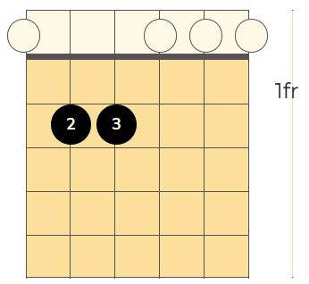

C2
All I Want is You (Capo 2nd fret)
G D Em Am Em D
All I want is You Jesus, All I want is you.
G D Em G
You are the source of all that I need Jesus,
C D G
All I want is You.

G D Em Am Em D
All I need is You Jesus, All I need is you.
G D Em G
You are the source of all that I need Jesus,
C D G
All I need is You.

G C D Em Am
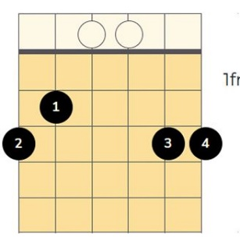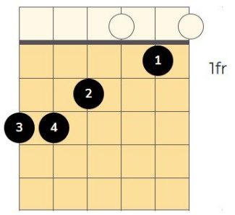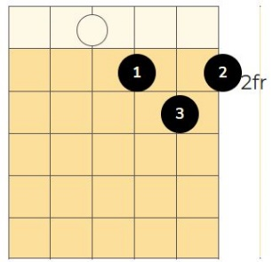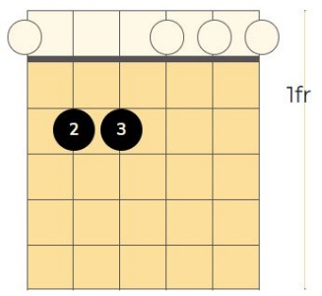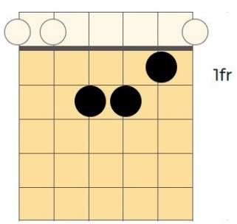
No Mosquitoes in Heaven (Capo 2nd fret)(Page 1 of 2)
By Paul Ellingsen
G D G C2 G
They’ll be no mosquitoes in heaven
C D G C2 G
No chiggers, no ticks, or rattlesnakes
G D G C2 G
They’ll be no mosquitoes in heaven
C D G C2 G
When you step inside those golden gates

G D G C2 G
They’ll be no out-houses in heaven
C D G C2 G
No toilets, toilet paper, or trash
G D G C2 G
They’ll be no out-houses in heaven
C D G C2 G
and you’ll never have to take out the trash

G D G C2 G
The lions will greet you in heaven
C D G C2 G
They’ll say “How are you let’s play”
G D G C2 G
And snuggle up close beside you
C D G C2 G
And say what a wonderful day

They’ll Be No Mosquitoes in Heaven (Page 2 of 2)
By Paul Ellingsen
G D G C2 G
The termites won’t eat at your mansion
C D G C2 G
Carpenter bees will build not destroy
G D G C2 G
And the ivy will not be poison
C D G C2 G
And the flowers will fill you with joy

G D G C2 G
But best of all there will be Jesus
C D G C2 G
The Lion who is the Lamb
G D G C2 G
The one who gave His life for you
C D G C2 G
Yeshua, The Great I Am
C D G C2 G
The Lion who is the Lamb
C D G C2 G
The forever and forever I Am

G C D C2
