Chords and lyrics for My Gravestone
by Cece and Me All songs written by Paul Ellingsen
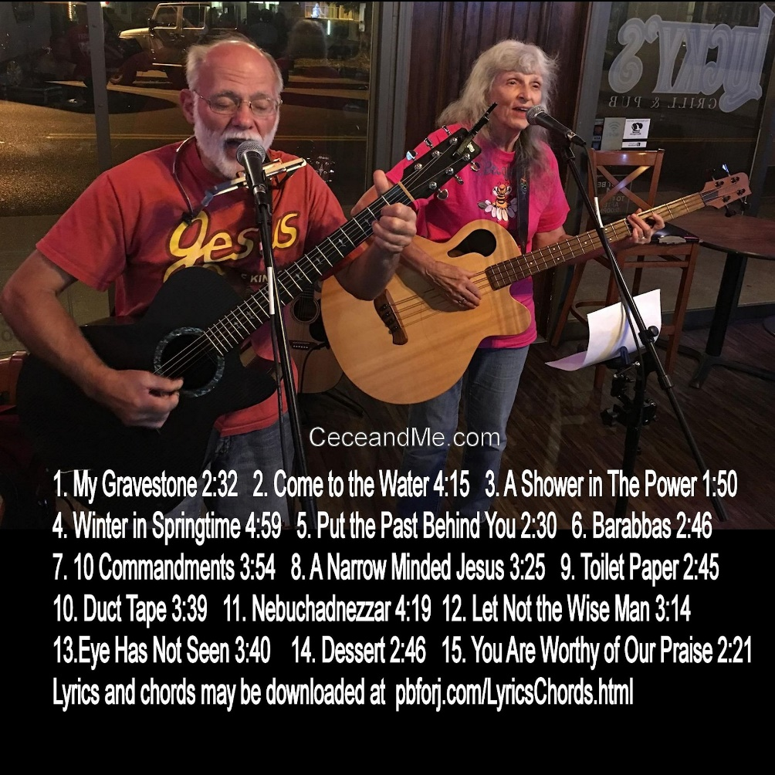
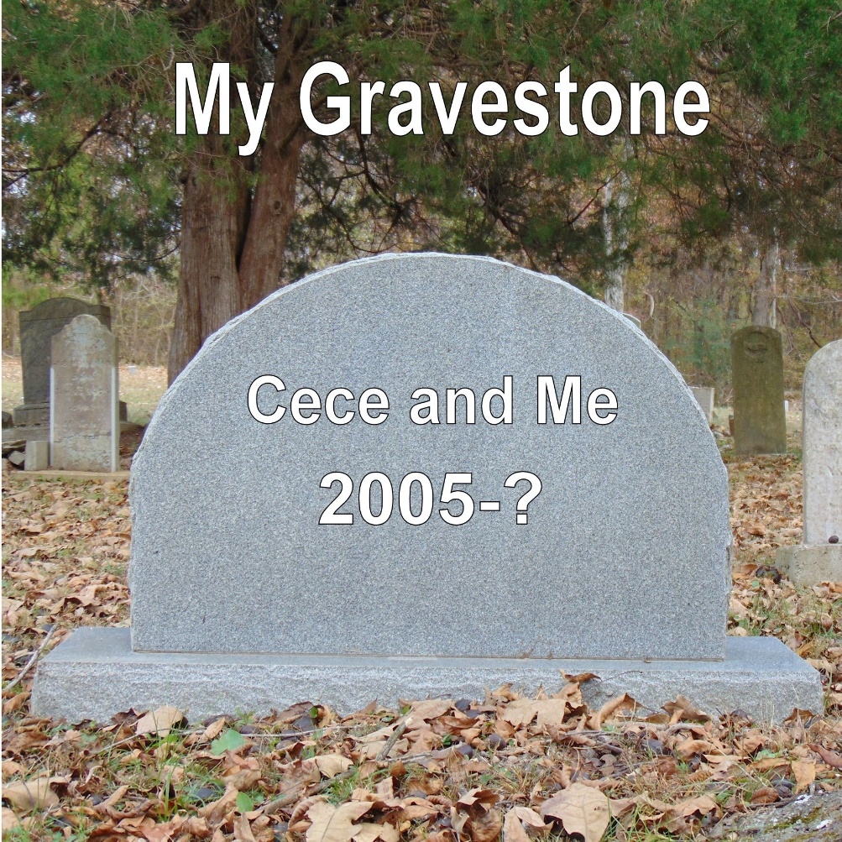
Chords for:
My Gravestone (Capo 2nd fret A Harmonica)

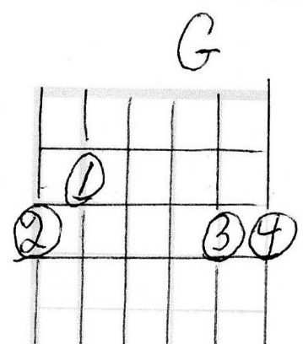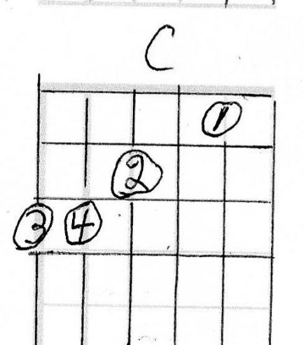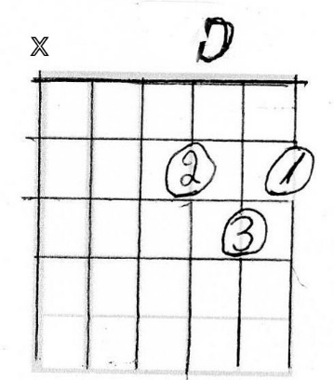

My Gravestone (Capo 2nd fret)
By Paul Ellingsen
So often I hear people say something like, “I want to be remembered for…” or “I want my tombstone to say…” But on that day I leave this earth the only thing that will matter will be What did Jesus think of my life? I hope it will be, “Well done, good and faithful servant; you were faithful over a few things, I will make you ruler over many things. Enter into the joy of your Lord.” Matt 25:21
G C D
I pray that Jesus be Blessed
G C G C D
Not by the clothes that I wear, Nor the way I’m dressed
G C D C D G
May I only seek to please thee, and not those on T V

Chorus:
G C D
I don’t care what they write on my gravestone
C G D G
Did he play well with others? Did he go it alone?
C D G
And when I see those gates of Glory
G C D G C D
Will Jesus say to me, Well done my Son,
C D G
You did it all for me

G C D
And when Nashville comes and knocks on my door,
G C G C D
May I not be impressed ‘cause you gave me more
G C D
For you give me life eternally
C D G
And forevermore I can say I’m free
Chords for:
Come to The Water (Capo 2nd fret, A Harmonica)
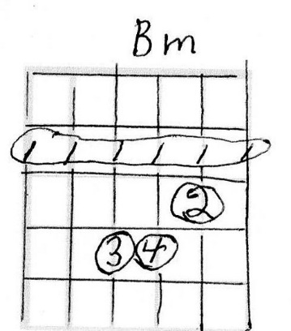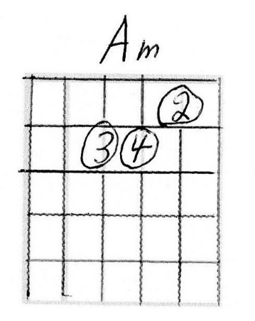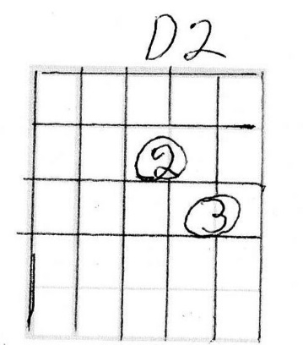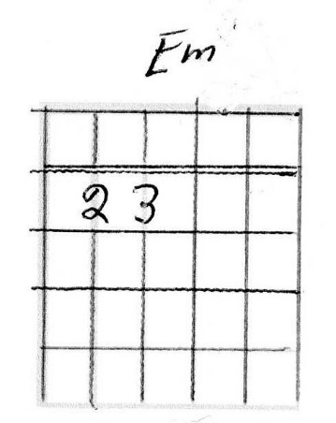

Come to The Water (Capo 2nd fret) (page 1 of 2)
(Isaiah 55, Psalm 34:8) By Paul Ellingsen
G Bm
You, who are thirsty, come to the water
Am D2
That you may buy and eat
G Bm
Buy milk and honey, buy without money
Am D2
Why waste your wages on what does not please?

Chorus:
Em C D2 G
Taste and see that the Lord is good
C D2 G
He’s been so good to me
Em C D2 G
Taste and see that the Lord is good
C D2 G
He has forgiven me.

G Bm
Incline your ear and, come to me
Am D2
Hear and your soul shall live
G Bm
And I will make an everlasting
Am D2
Covenant with you

Come to The Water (Capo 2nd fret) (A harp) (page 2 of 2)
(Isaiah 55, Psalm 34:8) By Paul Ellingsen

G Bm
Come seek the Lord while He may be found
Am D2
Call on Him while He is near
G
For My thoughts aren’t your thoughts
Bm
Nor your ways my ways
Am D2
My ways are higher than you can conceive.

Chorus (last time):
Em C D2 G
Taste and see that the Lord is good
C D2 G
He’s been so good to me
Em C D2 G
Taste and see that the Lord is good
C D2 G
He has forgiven me.
C D2 G
He’s been so good to me
C D2 G C2 G
And His truth will set you free

Chords for:
A Shower in the Power (Capo 2nd fret, A harmonica)

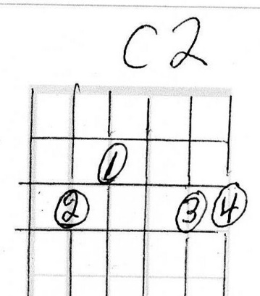

A Shower in the Power (Capo 2nd fret)
By Paul Ellingsen Inspired by Fonda Ducklee
Fonda Duncklee, who teaches our Sunday school class, said the Lord told her, “We need to take a shower in the power”

Chorus:
G C2 G
We need to take a shower in the power
D
A shower in the power of The Lamb

We need to take a shower in the power
C D G
Of the Holy Spirit and the great I AM (last time x3)

G C2 G
Jesus is the Alpha and Omega
D
The Beginning and the end He’ll always be

He will introduce us to The Father
C D G
We’ll live with Him throughout eternity (To chorus)

G C2 G
The Holy Spirit is our life’s companion
D
He will lead us where we ought to be

If we listen to Him completely
C D G
He will guide us in truth and set us free

Chords for:
It’s Winter in Springtime (G harmonica no capo)
Finger picked
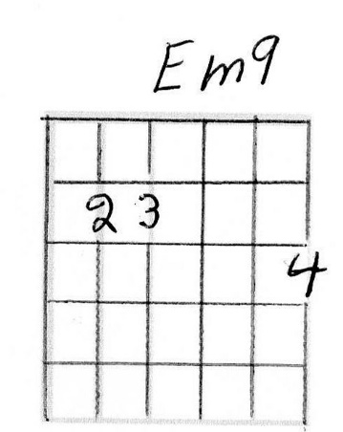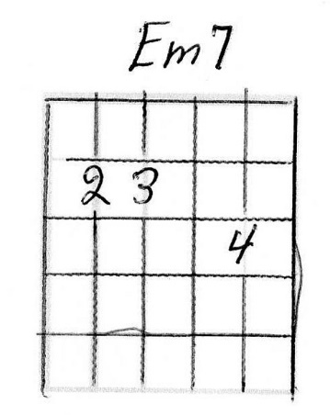
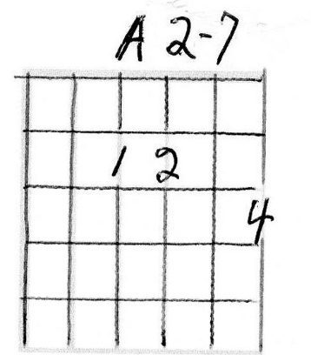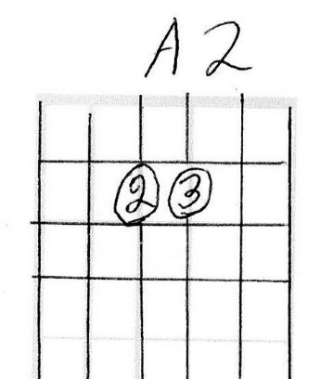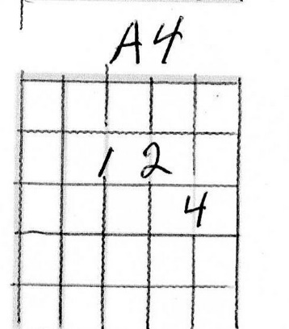
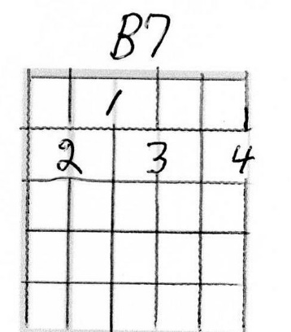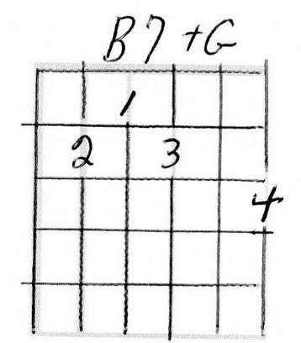It goes something like this:
Em9 Em9 Em9 Em Em7 Em A2-7 A2-7 A2-7 A2 A4 A2
It’s Winter in Springtime, the troubles on my mind,
Em9 Em Em7 B7 B7+G B7
Sometimes I don’t know, which way I should go
Em9 Em9 Em9 Em Em7 Em A2-7 A2-7 A2-7 A2 A4 A2
It’s Winter in Springtime, but my God is so kind,
Em Em9 Em Em7 Em B7 B7+G B7 Wm
He shows me the way that I should go.
If someone’s really interested in playing this, I suppose I could see if I can write it out in tab. Let me know Paul@PBforJ.com
It’s Winter in Springtime
by Paul Ellingsen
This song was written several years ago about a difficult time in my life.

Chorus:
Em A2
It’s Winter in Springtime, the troubles on my mind,
Em B7
Sometimes I don’t know, which way I should go
Em A2
It’s Winter in Springtime, but my God is so kind,
Em B7 Em
He shows me the way that I should go. (last time x3)

Em A2
When I was a young man, I went by my own plan,
Em B7
Full of my pride and arrogancy.
Em A2
But then I was humbled, brought low and tumbled,
Em B7 Em
So that I might taste of His excellency. To Chorus:

I pick the G on the 3rd fret bottom string on each chord
Em A2
I walked in by myself, saw His book on my shelf,
Em B7
He said to me, pick up and read.
Em A2
The answers are in there, You don’t know but I care.
Em B7 Em
My name is Jesus and I’ll set you free. To Chorus:

Em A2
We struggle and tumble, on this little humble,
Em B7
Piece of earth trying to make it go round.
Em A2
When Jesus paid the price, if we follow His advise,
Em B7 Em
His Love and His joy, it will abound. To Chorus:

Put the Past Behind You (Capo 2 A harmonica)
(2 Cor 5:17) By Paul Ellingsen
Therefore, if anyone is in Christ, he is a new creation; old things have passed away; behold, all things have become new. 2 Cor 5:17
G D G
Put the past behind you and start o-ver
C D G
Tomorrow will be another day
G D G
Ask Jesus’ forgiveness and start o-ver
C D G
Let all your grudges fly a-way

G D G
Put the past behind you and start o-ver
C D G
Jesus will give you a new day
G D G
In him news dreams will be a-bound-ing
C D G
And all our sins are washed away

G D G
Though your sins they be as scar-let
C D G
He will make them white as snow
G D G
He will restore the years locust have eat-en
C D G
Unforgiveness it must go

Chords for:
Barabbas (No capo, D harmonica)
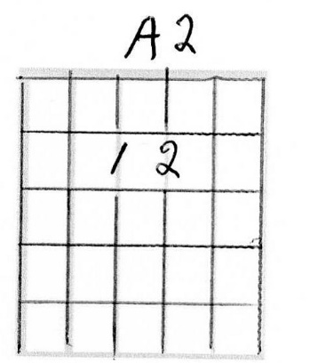
Barabbas (No capo, D harmonica)
(Matt 27:15-26, Mark 15:6-15, Lk13:13-25, Jn 18:39-40)
By Paul Ellingsen Inspired by the movie the Passion of the Christ
There is a scene in “The Passion of the Christ” where Barabbas is on the platform with Jesus and Pilate. He takes one look at Jesus, beaten and bloody, and for a moment he gets a very serious look on his face, like he realizes what really happening, and then he goes back to acting like a madman again. That scene is what inspired this song. The Bible doesn’t tell us what happened to Barabbas. Did he repent or did he go back to living a rebellious life? We don’t know, but this song speculates that he repented.
Em Em9 Em A2 A2-7 A2
1. What do I do now that Jesus took my place.
Em Em9 Em B7 B7+G B7
What do I do now that I’ve looked Him in the fa----ce.
Em Em9 Em A2 A2-7 A2
What do I do now that Jesus took my place?
Em Em9 Em B7 B7+G B7 Em Em9 Em
Repent and cry out loud (x2)
Em Em9 Em A2 A2-7 A2
2. How can I go back and live the life I’ve liv----ed?
Em Em9 Em B7 B7+G B7
Murder & destruction is all I had to gi----ve
Em Em9 Em A2 A2-7 A2
I looked in His eyes and I saw His tortured face.
Em Em9 Em B7 B7+G B7 Em Em9 Em
Repent and cry out loud (x2)
Em Em9 Em A2 A2-7 A2
3. Before I meet Jes-us my life was my own.
Em Em9 Em B7 B7+G B7
One look in His eyes and I could see the seeds that I’ve so-wn.
Em Em9 Em A2 A2-7 A2
My heart was so cold and as hard as a stone.
Em Em9 Em B7 B7+G B7 Em Em9
Re-pent and cry out loud (x3)

Chords for:
Ten Commandments (Capo 2nd fret, A harmonica)

Ten Commandments (Capo 2nd fret, A Harmonica)
Paraphrased words of the Lord musically arranged by Paul Ellingsen
(Ex 20:1-17, Dt:5 6-22)

G C2 G C2
I am the Lord your God who Brought you out of Egypt
G C2 D2
From bondage I delivered you

G C2 G C2
All other Gods you must forsake No image shall you make to
G C2 D2
Fall down and worship in place of Me

G C2 G C2
My name you shall honor I will not hold him guiltless
G C2 D2
Who takes my name in vain
To Chorus

G C2 G C2
Remember the Sabbath day And you shall keep it holy
G C2 D2
For in six days I made heaven and earth

G C2 G C2
Honor your father and mother Though they may not be perfect
G C2 D2
And a long life I promise you
To Chorus

Ten Commandments (Capo 2nd fret)
Paraphrased words of the Lord musically arranged by Paul Ellingsen
(Ex 20:1-17, Dt 5:6-22)

G C2 G C2
An innocent life you shall not take Adultery you shall forsake
G C2 D2
What others own you shall not steal

G C2 G C2
Of others truth shall you speak Do not let envy seek to
G C2 D2
Take con-tent-ment from your soul
To Chorus
Chorus
C D G
No better set of rules can you find
C D G
To please the one who made your mind
Em C D
Jesus knows the inside of your heart
C D G
With Him you can get a new start.

Last time:
C D G
He will write His Laws upon your heart.

Chords for:
A Narrow Minded Jesus (No capo, G harmonica)
A Narrow Minded Jesus (No capo, G Harmonica)
(John 14:6, 1st Timothy 2:5, Acts 4:12) By Paul Ellingsen
So often the response of an unbeliever to “Jesus is the only way to heaven” is, “That’s awful narrow minded of you” This is my answer to that.
Start with Chorus:
G C D
I believe in a narrow-minded Jesus
Em C D
He knows that He’s the only way
Em C D
You might think you can find others
C D G
But He’s the life, the truth, the way
So put your trust in Him today (Last time only)

G C D
He knows that He made the heavens
Em C D
He knows that He made the earth
Em C D
He knows in Him we find salvation
C D G
He knows in Him we find new birth, and so (To Chorus)

G C D
When I wandered far from His presence
Em C D
Lost in the depths of sin
Em C D
He searched ‘till He found me
C D G
Because He loves me deep within, and so (To Chorus)
Chords for:
Toilet Paper (Capo 2nd fret, A Harmonica)

Toilet Paper (Capo 2nd fret, A Harmonica)
(James 4:13-15) By Paul Ellingsen
I was talking to one of my son’s, Andrew, and we were talking about how the older you get the faster the years go by, and he said, “Yea Dad, It’s like a roll of toilet paper. The closer you get to the end the faster it goes” That sounded to me like it should be a song.
G D Em
Life is like a roll of toilet paper
C D G C
The closer to the end the faster it goes
G D G C G
So just make sure it’s Jesus that you know
C D G C G
(Last time) Just make sure that Jesus saved your soul

G C D G
You can spend your life with a-wards and a trophy wife
Em C D
Make it to the top of the heap,
G C D G
But it’ll soon be gone, like some sad song
Em C D
But there’s one who your soul can keep, cause (To Chorus)
G C D
This old world just doesn’t sat-is-fy
G C D G
All the glitter and gold, will leave ya high and dry,
Em C D
But there’s one who died to let you in
C D G
And only He can save you from your sins, cause(To Chorus)

Chords for:
Duct Tape (Capo 2nd fret, A Harmonica)

Duct Tape (Capo 2nd fret, A Harmonica)
(page 1 of 2) By Paul Ellingsen
Chris Clark, the pastor at Kentucky Lake Cowboy Church, had this Bible that was held together with duct tape. One morning Clay Campbell, the music director, said to Chris, “Ain’t no duct tape gonna heal a broken heart. Hey that sounds like a country song” I agreed and made a note of it on my bulletin and later wrote this song.

Chorus:
G D
Ain’t No Duct Tape Gonna Heal a Broken Heart
G
Only Jesus can do it right from the start

When your eyes are full of tears
C
And your heart is full of fear
G D G
Only Jesus can heal a broken heart
Last time: Only Jesus can heal a broken heart
Remember Jesus can heal a broken heart

G D
When you lover says that it’s time to go
G
And goes wandering away through the snow

Though her heart’s cold as ice
C
You’ve been nothin’ but nice
G D G
Remember Jesus can heal a broken heart

Duct Tape (Capo 2nd fret)
(page 1 of 2) By Paul Ellingsen

G D
When you job has taken your whole life
G
And given ya nothing but strife

When your boss says here’s the door
C
We don’t want ya here no more
G D G
Remember Jesus can heal a broken heart

G D
When even your family lets ya down
G
And it seem like there’s no one around

When your friends forsake you
C
And there’s nothin’ you can do
G D G
Remember Jesus can heal a broken heart

Chords for:
Nebuchadnezzar (capo 2nd fret, D Harmonica)
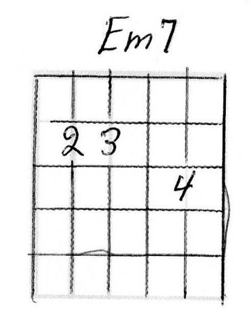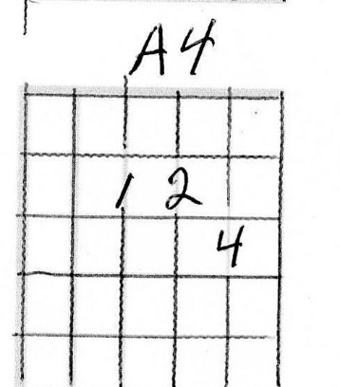
Nebuchadnezzar (Page 1 of 3) (capo 2nd fret, D Harmonica)
(Daniel 4)
This song is also on “The Road” CD but since I get more requests for this song than any other, I figured I’d rerecord it for this CD (Strummed with thumb) (I did my best but I may not have the chords in the exact correct location)
Intro: Em Em9 Em Em7 Em A2 A2-7 A2 A4 A2
Then play 1st verse with harmonica

Em Em9 Em Em7 Em A2 A2-7 A2 A4 A2
Is this not great
Em Em9 Em Em7 Em A2 A2-7 A2 A4 A2
Babylon That I have
Em Em9 Em Em7 Em A2 A2-7 A2 A4 A2
built for a royal
Em Em9 Em Em7 Em A2 A2-7 A2 A4 A2
dwelling By my
Em Em9 Em Em7 Em A2 A2-7 A2 A4 A2
mighty my mighty
Em Em9 Em Em7 Em A2 A2-7 A2 A4 A2
Power and for the
Em Em9 Em Em7 Em A2 A2-7 A2 A4 A2
honor of my ma-jes-
Em Em9 Em Em7 Em A2 A2-7 A2 A4 A2
ty

B7 B7+G B7 B7openE A2-7 A4 Am A2
Em Em9 Em Em7 Em A2 A2-7 A2 A4 A2
Em Em9 Em Em7 Em A2 A2-7 A2 A4 A2
Em Em9 Em Em7 Em A2 A2-7 A2 A4 A2
Thus
Em Em9 Em Em7 Em A2 A2-7 A2 A4 A2
spoke King Nebuchad
Em Em9 Em Em7 Em A2 A2-7 A2 A4 A2
nezzar, Full of
Em Em9 Em Em7 Em A2 A2-7 A2 A4 A2
pride and con-
Nebuchadnezzar (Page 2 of 3)
Em Em9 Em Em7 Em A2 A2-7 A2 A4 A2
ceit, And as he
Em Em9 Em Em7 Em A2 A2-7 A2 A4 A2
spoke, God was
Em Em9 Em Em7 Em A2 A2-7 A2 A4 A2
Angered and He
Em Em9 Em Em7 Em A2 A2-7 A2 A4 A2
issued this de-
Em Em9 Em Em7 Em A2 A2-7 A2 A4 A2
cree: You shall
Em Em9 Em Em7 Em A2 A2-7 A2 A4 A2
live like an
Em Em9 Em Em7 Em A2 A2-7 A2 A4 A2
animal, Driven
Em Em9 Em Em7 Em A2 A2-7 A2 A4 A2
from the presence of
Em Em9 Em Em7 Em A2 A2-7 A2 A4 A2
men Till you
Em Em9 Em Em7 Em A2 A2-7 A2 A4 A2
know God rules over the
Em Em9 Em Em7 Em A2 A2-7 A2 A4 A2
nations and places over
Em Em9 Em Em7 Em A2 A2-7 A2 A4 A2
them whosoever He
Em Em9 Em Em7 Em A2 A2-7 A2 A4 A2
will.
B7 B7+G B7 B7openE A2-7 A4 Am A2
Em Em9 Em Em7 Em A2 A2-7 A2 A4 A2
Em Em9 Em Em7 Em A2 A2-7 A2 A4 A2
King Nebuchad-
Em Em9 Em Em7 Em A2 A2-7 A2 A4 A2
nezzar woke seven years

Nebuchadnezzar (Page 3 of 3)
Em Em9 Em Em7 Em A2 A2-7 A2 A4 A2
Later And He praised the God of
Em Em9 Em Em7 Em A2 A2-7 A2 A4 A2
Heaven with these
Em Em9 Em Em7 Em A2 A2-7 A2 A4 A2
words:
Em Em9 Em Em7 Em A2 A2-7 A2 A4 A2
Now I , King Nebuchad-
Em Em9 Em Em7 Em A2 A2-7 A2 A4 A2
nezzar Praise, extol and
Em Em9 Em Em7 Em A2 A2-7 A2 A4 A2
honor the
Em Em9 Em Em7 Em A2 A2-7 A2 A4 A2
King, The
Em Em9 Em Em7 Em A2 A2-7 A2 A4 A2
King, the King of
Em Em9 Em Em7 Em A2 A2-7 A2 A4 A2
heaven, All of whose
Em Em9 Em Em7 Em A2 A2-7 A2 A4 A2
works are
Em Em9 Em Em7 Em A2 A2-7 A2 A4 A2
truth, And His
Em Em9 Em Em7 Em A2 A2-7 A2 A4 A2
ways, His ways are
Em Em9 Em Em7 Em A2 A2-7 A2 A4 A2
justice, and the
Em Em9 Em Em7 Em A2 A2-7 A2 A4 A2
proud He is able to put
Em Em9 Em Em7 Em A2 A2-7 A2 A4 A2
Down And the proud like
Em Em9 Em Em7 Em A2 A2-7 A2 A4 A2
me He is able to put down.
and the proud like me He is able to put down.
Chords for:
Let Not The Wise Man (capo 2nd fret A harmonica)

Let Not The Wise Man (capo 2nd fret)
Jeremiah 9: 23-24 musical arrangement by Paul Ellingsen
C D G
Let not wise man glory in his wisdom.
C D G
Let not the Strong man glory in his might.
C D G
Let not the rich man glory in his ri-ches.
C D C D
But let him who glories, glory in this,
C D G
In that he knows and that He understands Me.
C D G
For I am the Lord of loving kindness.
C D G
Judgment and ri-ghteous-ness in the earth.
C D G C
For in these things I do de-light.
C D C D
Let him who glories, glory in this
C D G
In that he knows and that he understands Me.

Chords for:
Eye Has Not Seen (No capo G harmonica)

I’m not sure the name of the chords that I’m using in the chorus, so I’ll just call them DDEA and DCDG
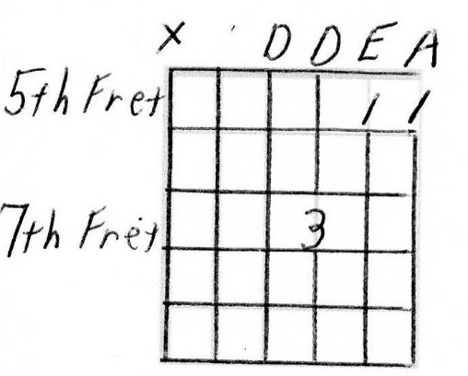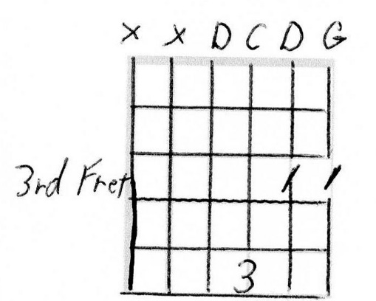
Eye Has Not Seen (No capo G harmonica)
I Corinthians 2:9 by Paul Ellingsen

G C G C
1. Eye has not seen, Nor has ear heard,
G D G
Nor has it entered into the hearts of men,
(0755) (0533)
(DDEA) (DCDG) G
What God has prepared for those who love Him.
(DDEA)
What can compare to
(DCDG) G
What God has prepared for those who love Him.

G C G C
2. So why do we live, As if this is all there is,
G D G
As if we knew, that we'd be here tomorrow.

Chorus:
(DDEA)
For what can compare,
(DCDG) G
to what God has prepared for those who love Him
(DDEA)
What can compare to
(DCDG) G
What God has prepared for those who love Him

G C G C
3. And why do we not give, the best we have to give,
G D G
When there’s nothing on this earth that compares to His glory.
(to chorus)

G C G C
4. Jesus said I go, to prepare a place for you,
G D G
That where I am you may be also.
(to chorus)

G C G C
5. Jesus help me please, as I go on my way,
G D G
To be a man who seeks your reward only.
(to chorus, then repeat first verse, then repeat chorus
Chords for: Dessert (No Capo G harmonica)

Dessert (No Capo G harmonica) (Page 1 of 2)
(Rev 13:16-17, 20:1-3) By Paul Ellingsen
G
Don’t fill up before desert comes,
C
The best is yet to be.
D
When the one who died and rose for you
G
Has come to set us free.

G
He’ll ful-fill your deepest longings
C
For life and liberty
D
When He, comes and breaks your chains to earth
G
And His beauty you will see

G
Then satan will be cast down
C
To a pit and locked away
D
For a thousand years peace will reign
G
And joy shall rule the day

Dessert (Page 2 of 2)
(Rev 13:16-17, 20:1-3 By Paul Ellingsen
G
You’ll be so glad that the evil mark,
C
You refused to take
D
And the stuff that you had you held so dear,
G
Will seem so small that day.

G C
And we’ll cry Halleluiah, we’ll cry Halleluiah
D G
we’ll cry Halleluiah Praise Jesus Name

G
And the Spirit sings His praises
C
The Father says well done
D
And we’ll sing His praise forever
G
And God’s light will be the sun

G C
And we’ll sing Halleluiah, we’ll sing Halleluiah
D G
we’ll sing Halleluiah and we’ll Praise Jesus Name

Chords for: You Are Worthy of Our Praise (Capo 2nd fret A harmonica)

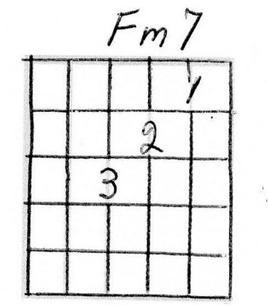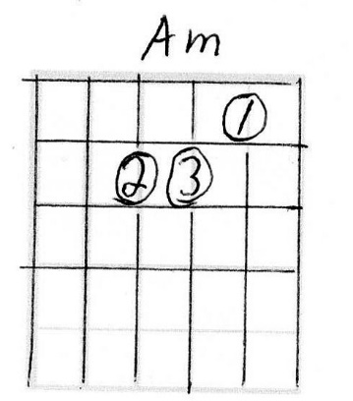

You Are Worthy of Our Praise (Capo 2nd fret)
(Revelation 4:11 & 5:9) By Paul Ellingsen
G Fm7
Oh the sunset in the mountains
G Fm7
And the breeze upon the lake
G Fm7
And the feeling in the morning
G Fm7
When you first a-wake

C Em D2
So I’ll Praise your holy name
C Em D2
And the wonder of Your ways
C Em D2
Your glory reaches past the sky
C Em D2
Yet you re-gard one such as I

Am D G C
Je---sus Je---sus
C D2 G
You are worthy of our praise

Am D G C
Je---sus Je---sus
C D2 G
You are worthy of our praise (X3)

